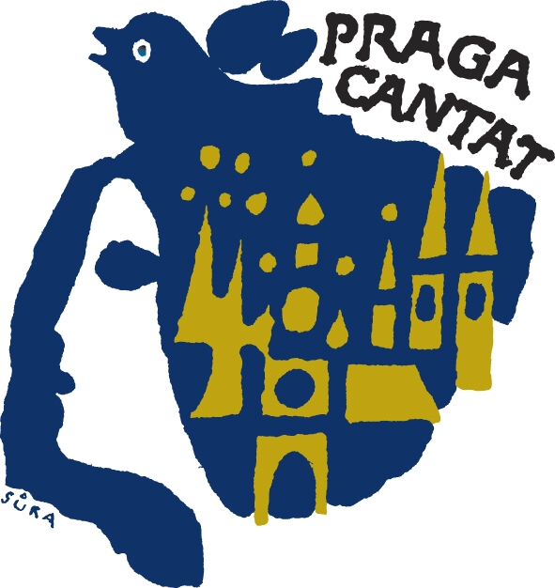

Náměstí Míru 15
120 00, Praha 2
Czech Republic
Tel: +420 222 516 189
Fax: +420 224 219 480 koslerova@bohemiaticket.cz
kotrcova@bohemiaticket.cz
www.bohemiafestival.cz

Programme

PRAGA CANTAT - GRAND PRIX

25th Anniversary International Choir Competition and Festival

Prague, 27. – 30.10. 2011

Praga Cantat festival of which the 25th anniversary edition will be held from 27th to 30th of October 2011 has become one of the most important choir events in Prague. The previous 24 events was attended by 705 choirs from 25 countries. The total number of singers who have visited this Prague's festival is 28000.
Praga Cantat festival is not an exclusive competition. Alongside the excellent choirs there are also choirs at the beginning of their development and those which want to match with the others and feel the beautiful atmosphere of the competition. International and professional jury judges not only the performances of the choirs but also gives valuable recommendations which may help the choir leaders in their following work.
Alongside the traditional categories there are also new categories for the year 2011 announced and the festival will peak with the GRAND PRIX competition.
We are looking forward to see all our guests!

Preliminary programme:

27.10. 2011 / Thursday
Arrival to Prague and meeting with your Czech assistant, transfer to the hotel
individual programme
18:30 Choir Director and Vice-President (2 choir members) will take part in
welcome reception

28.10. 2011 / Friday
Group breakfast in the hotel
10:00 Official opening concert at the National House perfomed by Czech famous choir
“Bambini di Praga”
Time for lunch
14:00 Competitions for choirs in all categories takes place in the National House
At the same time, the performances of festival choirs take place at senior citizens homes
Competition continues until the evening

29.10. 2011 / Saturday
Group breakfast in the hotel
10:00 Performances of festival´s choirs participating in Category G
Guided city tour including visit of the Prague Castle for the categories A - F
Time for lunch
Afternoon Competition for GRAND PRIX 2011
20:00 Closing ceremony + awards ceremony for choirs, after which the compulsory pieces are
sung together, performance of the GRAND PRIX winner
Following the closing ceremonies, all choirs come together to enjoy a farewell evening of
music and dance at the National House

30.10. 2010 / Sunday
Group breakfast at the hotel and check-out of the hotel
Departure
We can prepare you special programme in case you want to extend your staying in Prague

