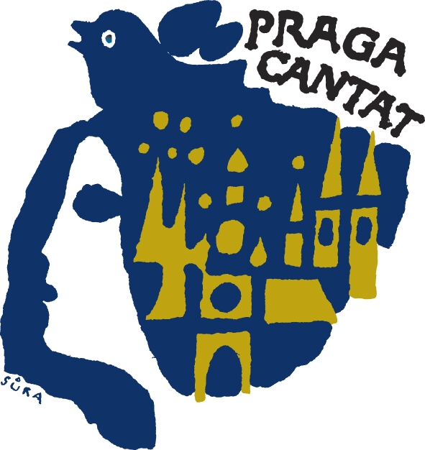
Competition rules

PRAGA CANTAT - GRAND PRIX

25th Anniversary International Choir Competition and Festival

Prague, 27. – 30.10. 2011

1. General provisions
  - Only amateur choirs may participate, though the conductor may be professional.
  - There is no limit on the number of members of a choir.
  - A competition performance may not last longer than 15 minutes, including the arrival and departure of the choir.
  - The programme of a competitive performance must be approved in advance by the festival steering committee.
  - On the basis of the quality of the performance the jury will divide choirs in individual categories into gold, silver and bronze and name the category winner.

    - gold - excellent performance
    - silver - very good performance
    - bronze - good performance
  - The winners of each category will compete for Grand Prix Praga Cantat 2011

2. Categories

The competition will take place in 6 basic categories, the 7th category is non-competitive:

- category A male-voice choirs
- category B female-voice choirs
- category C mixed choirs
- category D girls’, boys’ and mixed youth choirs aged 14 to 24
- category E choirs with a programme of sacred compositions
- category F folksong – male-voice, female-voice, mixed and youth choirs
-------------------------------------------------------------------------------------------------------------------
- category G festival (non-competitive – only for foreign choirs)
According to the number of entered choirs some categories can be either joined or split.

3. Competitive performances

Categories A, B, C – male-voice, female-voice and mixed choirs (with obligatory composition)
- The competitive programme comprises a maximum of five unaccompanied compositions (a cappella), including obligatory composition.
- The selection of compositions may be made from diverse epochs and styles, e.g. old masters,
romantic period, contemporary music, folksong, etc.
- Obligatory compositions:

  - male-voice choirs - Bedřich Smetana: Věno / Dowry
  - female-voice choirs - Bedřich Smetana: Má hvězda / My star
  - mixed choirs - Antonín Dvořák: Napadly písně / Fallen songs

- The festival director may make an exception in the case of choirs which for serious reason
cannot rehearse the obligatory composition. However, these choirs cannot be placed higher
than silver. The scores of the obligatory compositions may be requested from the festival
organiser.

Category D – girls’, boys’ and youth mixed choirs
- Girls’, boys’ and youth mixed choirs aged 14 to 24 can enter this category.
- The competitive programme does not contain an obligatory composition and will comprise 5 compositions at most of various styles and genres, of which one may be accompanied by 1 – 2 acoustic instruments.

Category E – choirs with a programme of sacred compositions
- This category is for male-voice, female-voice, mixed and young choirs
- The competition programme comprises a maximum of five sacred compositions without accompaniment (a cappella).
- The compositions may be from diverse epochs and styles – old masters, romantic period, contemporary music.

Category F – Folksong
- This category is for male-voice, female-voice, mixed and young choirs.
- The choirs will perform 3 to 5 folksongs (with an emphasis on songs from the choir’s own country). The compositions may be accompanied by folk instruments (not piano).
- However, at least 1 composition must be performed without accompaniment (a cappella).

Category G – non-competitive, festival (only for foreign choirs)
- This category is for male-voice, female-voice and mixed choirs.

There is no restriction on the number of singers or age.
- Every choir will prepare the programme of its choice lasting 15 minutes at most. The compositions can have a piano accompaniment, but at least 1 composition must be

a cappella.
- A member of the competition jury will listen to the programme and in an interview with the choirmaster will offer a specialist analysis of the performance and write a short evaluation for the choirmaster.
- No sequence of choirs will be stipulated in this category!
- Choirs participating in this category will perform a composition by J. C. Vodňanský entitled

“IN PRAGA CARMINA RESONANT” (a simple homophonic four-part piece), which everyone will

sing together on the final evening of the festival.

4. Grand Prix of Praga cantat 2011

The winners of each category and other choirs according to the jury’s choice continue further to compete for Grand Prix.

In the Grand Prix competition the choirs sing 3 songs of their own choice for up to 10 minutes of performance. The choir can include only 1 song from the previous program in its category. Also the choice of the program will be judged by the jury. Two songs must be a capella and one can be accompanied by 1 - 2 acoustic instruments. The order of the choirs performances will be drawn.

The Grand Prix PRAGA CANTAT 2011 winner will be the one who gets the most votes by the secret ballot of the jury.

5. The Jury

The jury is international and judges the performance quality from professional aspects of the performance technique and artistic interpretation of the songs. The decision is final and secret until the results announcement.

6. Competition prizes
- All participating choirs will receive a diploma
- Category winners will receive a cup
- The Grand Prix winner will receive a cup and financial bonus.
- The jury may decide to award special prizes in each category:
  - a prize for outstanding conducting
  - a prize for the best selected programme
  - a prize for the most effective performance of a folksong
  - a prize for an outstanding performance of a piece by a Czech composer or Czech folksong (only for foreign choirs)
  - other special prizes at the discretion of the jury

7. Announcement of results
The results will be announced and the prizes awarded at the end of the festival. Choirs of categories A, B and C will jointly sing the obligatory composition of their respective categories under the direction of competing choirmasters. Category G choirs will sing the composition “IN PRAGA CARMINA RESONANT” together. The final evening ends with a social dance.

